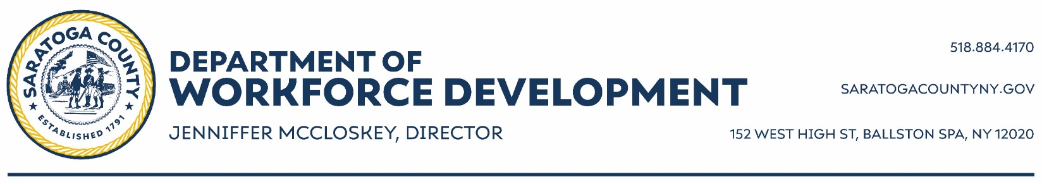

EMT Career Pathway Program
Application Form

You MUST fill out ALL sections of the application form to be considered.
(PLEASE BE SURE TO WRITE NEATLY SO WE CAN READ EVERYTHING ON YOUR APPLICATION)

Today’s date is: ______ /______ / 2024

Full Name________________________________________ Social Security Number_________ /________ /_________

Address _____________________________________________________________________________________________
(Street) (City) (Zip Code)
Town you live in if different from your address: _________________________________________________________

Your Home Phone #: ____________________________ Your Cell Phone #: _________________________________

Parent/Guardian Phone #: _________________________ Email: ______________________________________

Additional way to contact you (phone, email, fb messenger, etc.): _____________________________________

Birth Date: ______/______/______ How old are you right now? _______ Gender: ____________________________

If you are a male, 18 years old or older, have you registered with selective service? Yesq Noq

ELIGIBILITY QUESTIONNAIRE (ALL Questions MUST Be Answered to Be Considered!) IF UNDER 18

How many immediate* family members live in the applicant’s home (incl. applicant)? ________

Does the applicant’s family receive Food Stamps (in the last 6 months)? Yesq Noq

Does the applicant receive: Family Assistance/Safety Net? Yesq Noq

Does the applicant receive: free healthcare (Medicaid)? Yesq Noq

Does the applicant’s family receive: HEAP? Yesq Noq

Does the applicant receive: SSI? Yesq Noq

Is the applicant in foster care? Yesq Noq

Does the applicant have any physical, emotional or learning disabilities or an IEP? Yesq Noq

If yes, does the applicant receive:

a) Medicaid Waiver: Yesq Noq

b) Supplemental Security Income: Yesq Noq

INTEREST IN PROGRAM:
Please explain why you want to be enrolled in this program and what you hope to accomplish through this experience.
_________________________________________________________________________________________________________

_________________________________________________________________________________________________________

_________________________________________________________________________________________________________

COMMUNITY INVOLVEMENT:
Please list any community organizations that you belong to such as scouts, school clubs, civic organizations, and school activities:

________________________________________________________________________________________________________

Do you have reliable transportation to lab and lecture locations? Yesq Noq

ETHNICITY INFORMATION (OPTIONAL)
CHECK ONE

qWHITE q BLACK qHISPANIC qASIAN qAMERICAN INDIAN qPACIFIC ISLANDER qOTHER

Where did you obtain this application? _______________________________________________________

CERTIFICATION:
I certify that the information on this application is correct to the best of my knowledge. I understand that submitting an application in no way guarantees an interview or placement in training.

___________________________________________________________ _____________________
Applicant’s Signature Date

____________________________________________________________ _____________________
Signature of Parent/Guardian if Applicant is under the age of 18: Date

Application Deadline is December 29, 2023

PLEASE RETURN THIS APPLICATION TO:
Saratoga County Department of Workforce Development
152 West High Street, Ballston Spa, NY 12020
or email to:
jmccloskey@saratogacountyny.gov

