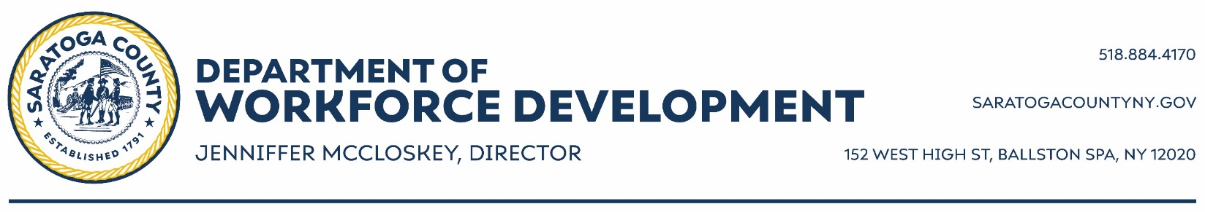
EMT Career Pathway Program
Assessment Form

Youth Name: Date:

Long Term Career Goal:

What skills do you have/what are you good at doing?

A problem and how you solved it:

Tell me something about yourself:

Tell me something you are proud of:

Why do you want to participate?

What is your plan after high school?

Notes:

