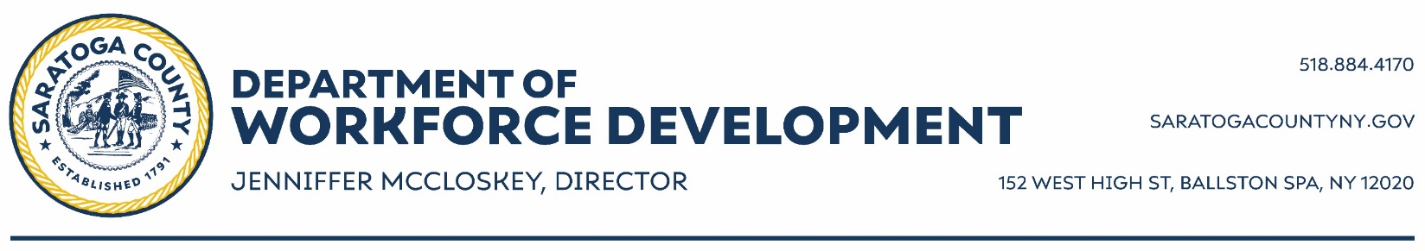

EMT Career Pathway Program
Emergency Information Form

Name: Age:
Phone: Can you receive text messages at this number? Yes No
Address:
List any allergies:
Do you have an EpiPen? Yes No
Anything else we should know about in case of an emergency:

Emergency Contact Information
First Contact
Name: Relationship to Youth:
Primary Phone: Secondary Phone:
Second Contact
Name: Relationship to Youth:
Primary Phone: Secondary Phone:

